LASER RANGER FINDER REPORT

## Prof. Mark Yim

## Chaitanya Bhargava, Chao Liu

FOV camera = **50deg**

So for the laser line to reach edge of the image at inf, angle of laser wrt to camera = **25deg**

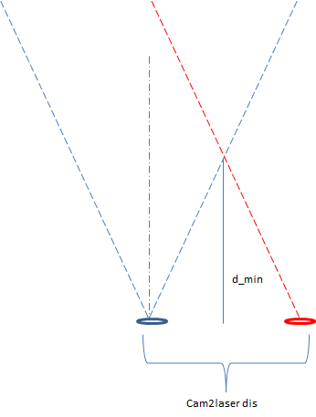

Hence for d_min = **7 cm** (1 SMORE length) from geometry we get

Cam2laser distance = **6.5 cm (approx.)**

So using various camera-to-laser distances and the fixed laser angle (25 deg) we obtained pixel data at various distance from a fixed screen.

The test setup was moved from a fixed starting position and moved away till the laser line was almost out of the camera frame.

The data points are the average of the middle 40 pixels of the laser line.

Various curves were fitted to the dataset the results obtained are as such:-

|  |  |  |  |  |  |
| --- | --- | --- | --- | --- | --- |
| **Cam2laser** | **6cm** |  |  |  |  |
| **Size** | **Fit** | **Eq** |  |  |  |
| 12 | 0.023 | y = 6222.066/(177.843 + x) - 1.417 - 0.004*x |  |  |  |
| 10 | 0.023 | y = 5719.818/(170.181 + x) - 0.006*x |  |  |  |
| 8 | 0.023 | y = 7711.047/(199.729 + x) - 5.207 |  |  |  |
| 6 | 0.054 | y = 4968.280/(144.969 + x) |  |  |  |
| |  | | --- | |  | |  |  |  |  |  |
|  |  |  |  |  |  |
|  |  |  |  |  |  |
|  |  |  |  |  |  |
|  |  |  |  |  |  |
|  |  |  |  |  |  |
|  |  |  |  |  |  |
|  |  |  |  |  |  |
|  |  |  |  |  |  |
|  |  |  |  |  |  |
|  |  |  |  |  |  |
|  |  |  |  |  |  |
|  |  |  |  |  |  |
|  |  |  |  |  |  |
|  |  |  |  |  |  |
| **Cam2laser** | **7cm** |  |  |  |  |
| **Size** | **Fit** | **Eq** |  |  |  |
| 12 | 0.014 | y = 2.647 + 5341.111/(165.055 + x) - 0.002*x |  |  |  |
| 10 | 0.015 | y = 34.913 + -33.950*x/(176.120 + x) |  |  |  |
| 8 | 0.015 | y = 0.977 + 5968.167/(175.839 + x) |  |  |  |
| 6 | 0.022 | y = 6544.222/(188.057 + x) |  |  |  |
| |  | | --- | |  | |  |  |  |  |  |
|  |  |  |  |  |  |
|  |  |  |  |  |  |
|  |  |  |  |  |  |
|  |  |  |  |  |  |
|  |  |  |  |  |  |
|  |  |  |  |  |  |
|  |  |  |  |  |  |
|  |  |  |  |  |  |
|  |  |  |  |  |  |
|  |  |  |  |  |  |
|  |  |  |  |  |  |
|  |  |  |  |  |  |
|  |  |  |  |  |  |
|  |  |  |  |  |  |
| **Cam2laser** | **8cm** |  |  |  |  |
| **Size** | **Fit** | **Eq** |
| 12 | 0.012 | y = 8.193+ 4551.809/(133.192 + x) - 0.005*x |  |  |  |
| 10 | 0.019 | y = (6633.851 + 3.612*x)/(157.815 + x) |  |  |  |
| 8 | 0.019 | y = 3.585 + 6075.750/(158.025 + x) |  |  |  |
| 6 | 0.053 | y = 8541.521/(210.343 + x) |  |  |  |
| |  | | --- | |  | |  |  |  |  |  |
|  |  |  |  |  |  |
|  |  |  |  |  |  |
|  |  |  |  |  |  |
|  |  |  |  |  |  |
|  |  |  |  |  |  |
|  |  |  |  |  |  |
|  |  |  |  |  |  |
|  |  |  |  |  |  |
|  |  |  |  |  |  |
|  |  |  |  |  |  |
|  |  |  |  |  |  |
|  |  |  |  |  |  |
|  |  |  |  |  |  |

|  |  |  |
| --- | --- | --- |
| **Cam2laser** | **6.5cm** |  |
| **Size** | **Fit** | **Eq** |
| 12 | 0.002 | y = 3.074 + 4613.041/(176.037 + x) - 0.002*x |
| 10 | 0.005 | y = 1.473 + 69.161/(2.492 + 0.0132*x) |
| 8 | 0.005 | y = 1.496 + 5209.011/(187.842 + x) |
| 6 | 0.022 | y = 6117.548/(210.792 + x) |



# Sources of Error

1. Test setup human error
   1. Camera not perfectly straight
   2. Laser not exactly 25deg
   3. Distance readings not accurate
2. Data latency

Cause of these plus other sources of error it is recommended that every time a new fixture is made it should be re-calibrated.